

**Further applications include recreating films with specific art styles, creating car rendering image, and remixing two art works recognition task.**

**Segmentation**

Style can be transferred to semantic segmentations in the content image

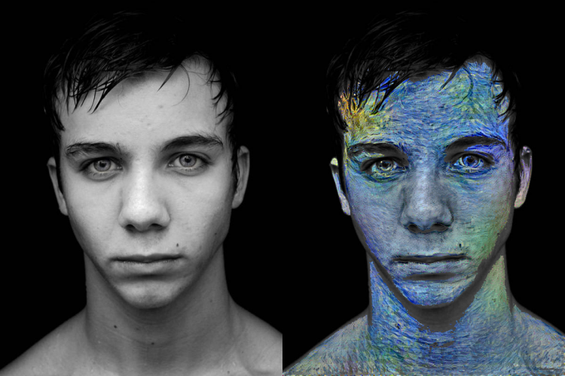 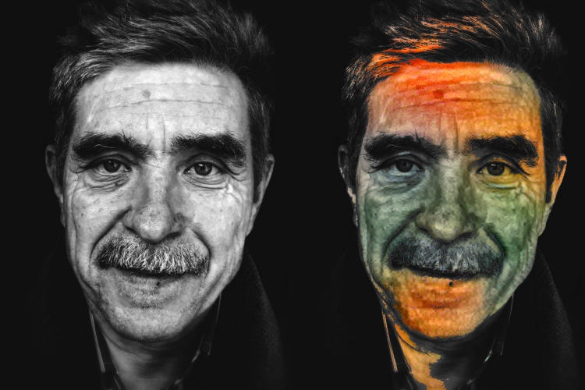

We can see that the best results are achieved by a combination of many different layers from the network, which capture both the finer textures and the larger elements of the original image

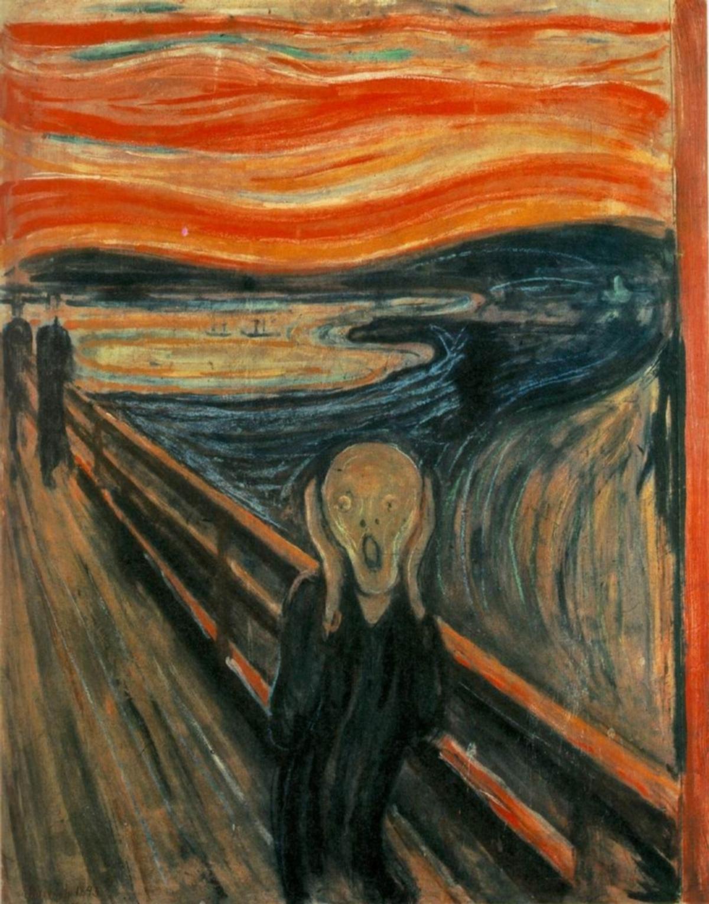

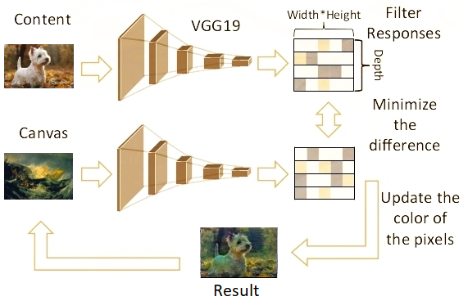

**Increasing stages of style extraction**

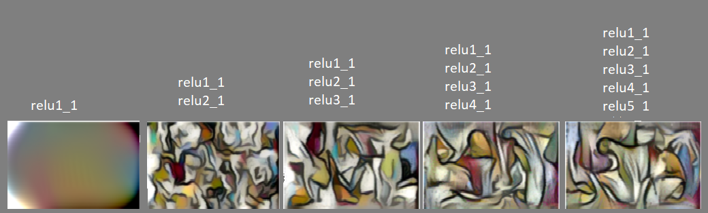

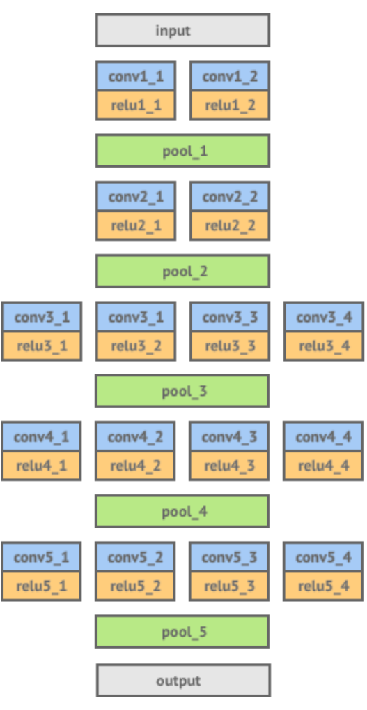

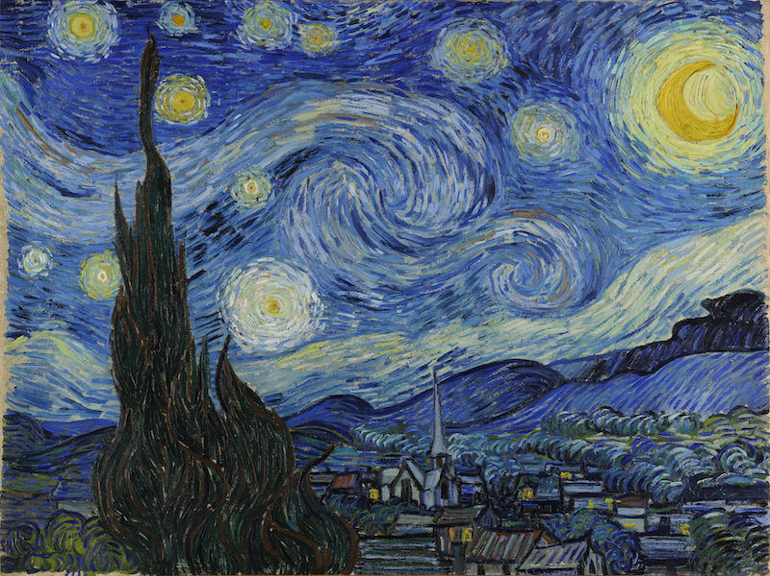 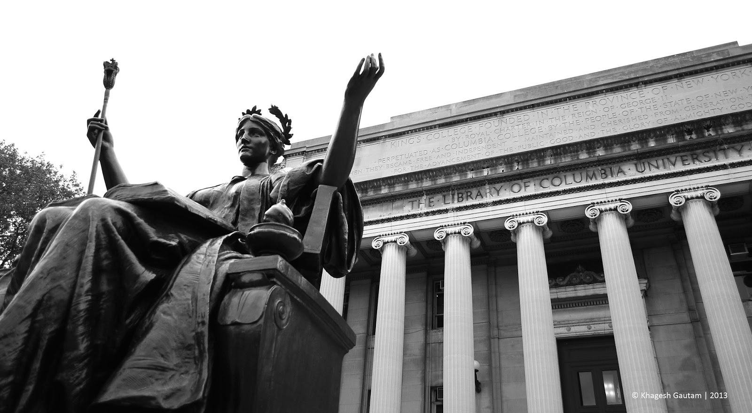



**ECBM 4040 Neural Network and Deep Learning**

**Guide:** Prof. Zoran Kostic **Team:** Vinay Kale, Siyu Liu, Yue Wen

We built a Convolutional Neural Network to extract style to apply to another image, and extend this method to videos.





